Task 2
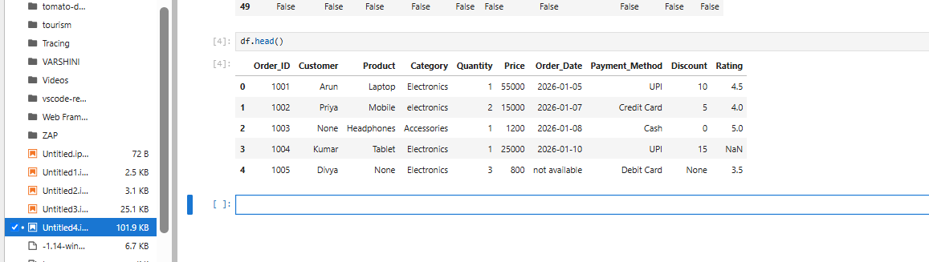
df.head() is used to read the first 5 rows of the data.

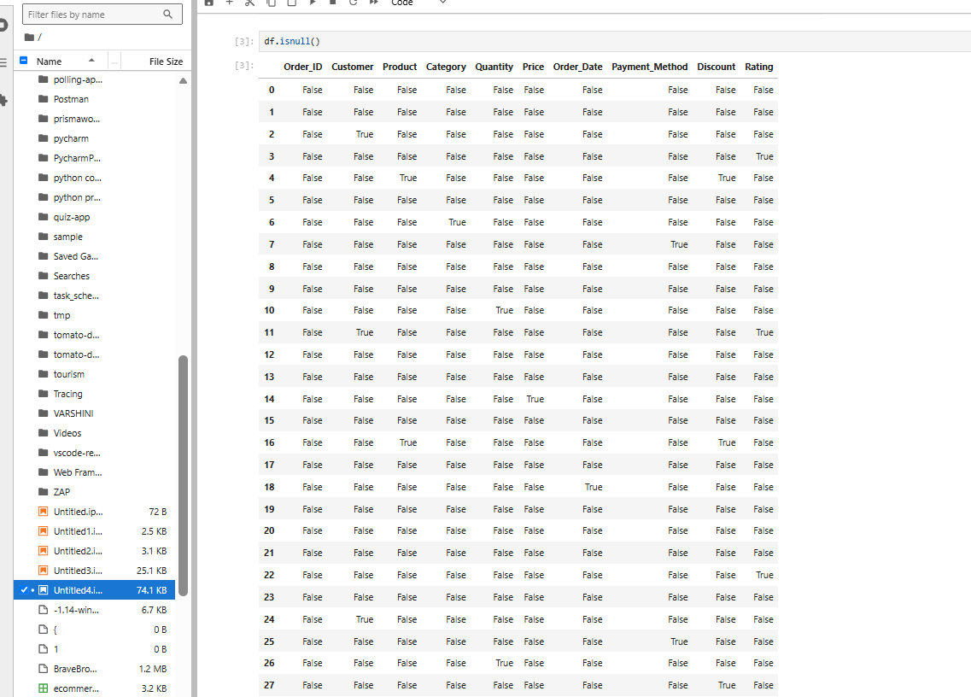
df.isnull() is used to identify if any data is missing.

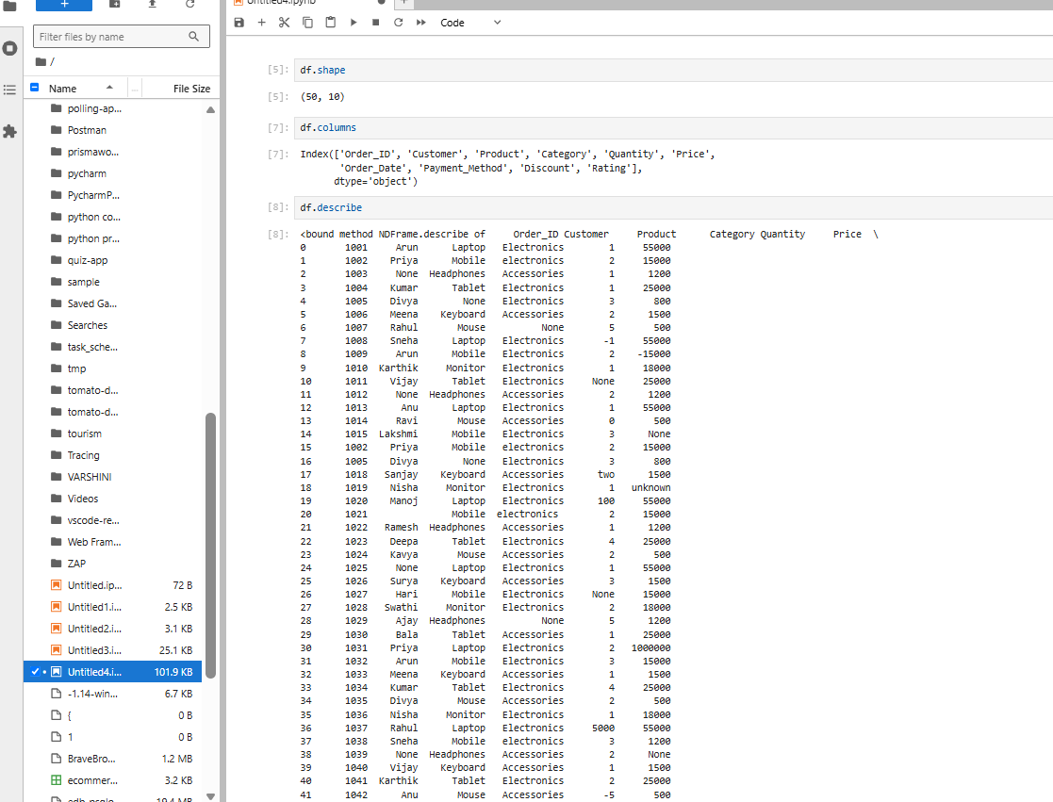

df.shape is an attribute. It helps to identify the no. of rows and cols in a dataset.
df.describe is used to describe all the data that are available in the dataset.
df.columns is used to specify the column names in the dataset.

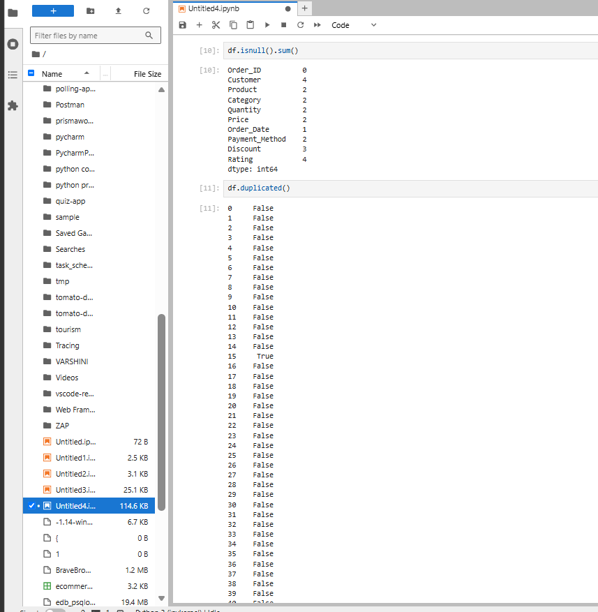

df.duplicated() is used to list the data that are duplicates, it is specified as true for duplicated data, and false for non-duplicate data.

df.isnull().sum() is used to specify the count of values that are missing in the dataset.

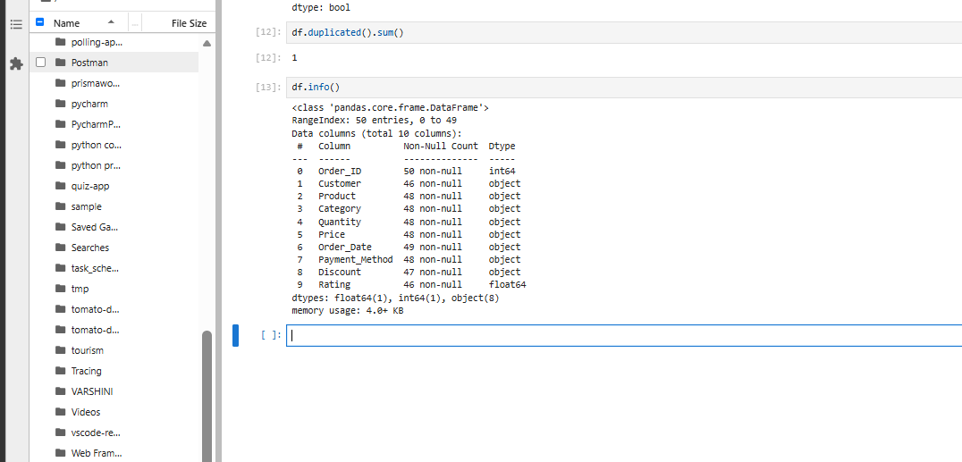
df.duplicated.sum() is used to specify the count of data that are duplicated in the dataset.

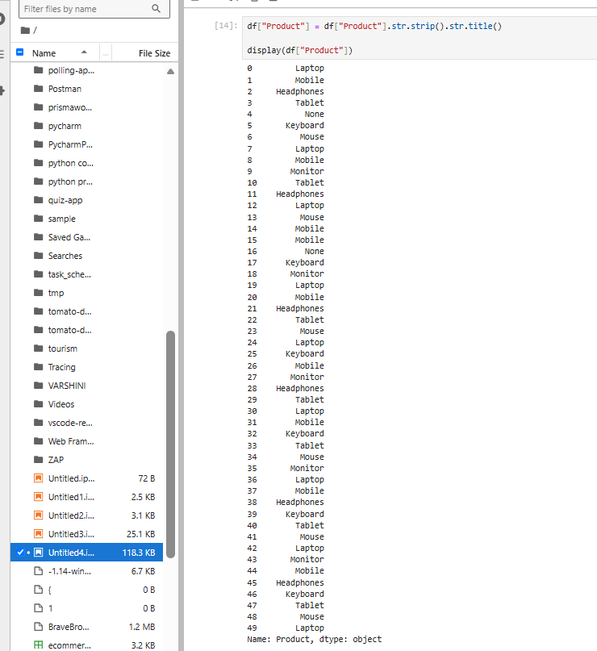

str.stripe() is used to remove the white space in front and back of the text, and makes them aligned.

str.title() is used to give a uniform naming standard to all the text that are specified.
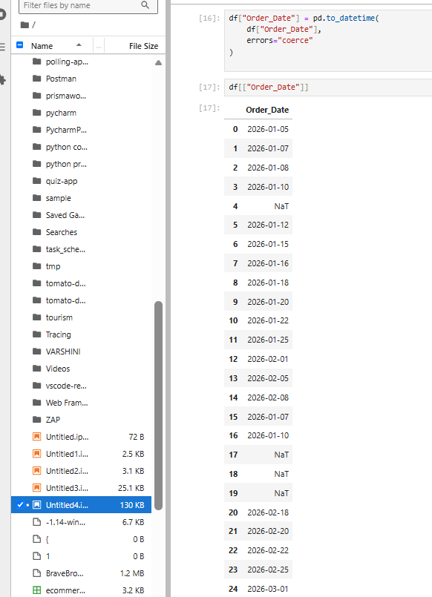
This is used to list all the order_date data and the invalid data are specified as NaT.

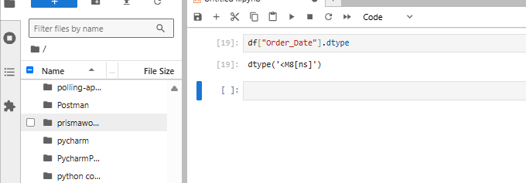
The dtype('<M8[ns]') is a NumPy machine-specific internal representation for datetime64[ns].
Breakdown of the Syntax
- <: Indicates little-endian byte order (the way bytes are ordered in memory for your specific CPU architecture; > means big-endian).
- M8: The internal NumPy type code for datetime64 (m8 lowercase is used for timedelta64).
- [ns]: The time unit, which stands for nanoseconds.

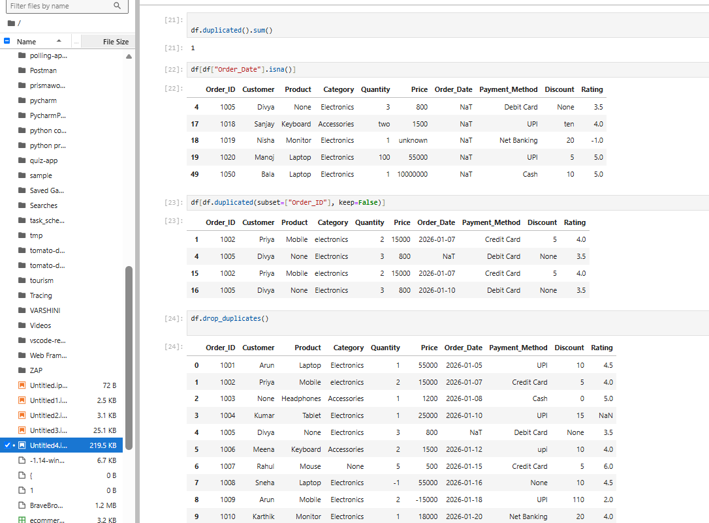

Here we are counting the duplicated data and identifying the data which is missing using isna().
df.drop_duplicates() is used to drop/remove the data that are duplicated.

